Common Mosses and Lichens

Moss
Bryum capillare  Capillary thread moss | Acrocarp  A generalist -soil, concrete, rooftop  Note: leaf shape, silvery point  Riparian | 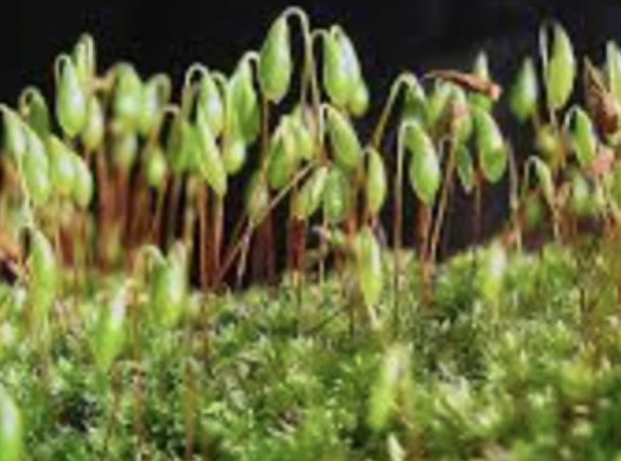
Dicranum scoparium  Broom moss | Acrocarp  Rotten logs, wood, rock, soil  Note: curved leaves swept to one side | 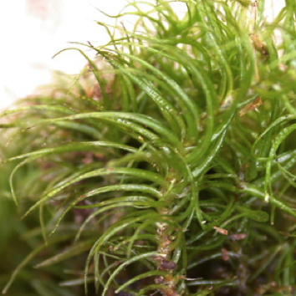
Dicranum (Orthodicranum) tauricum  Velvet moss | Acrocarp  Rotten logs, wood  Note: small, leaf tips break easily  Coniferous forest | 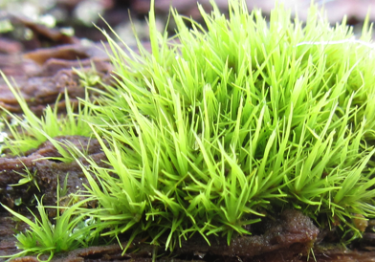
Eurhynchium (Kindbergia) oregana  Oregon beaked moss | Pleurocarp  A generalist –soil, rotten logs, rock, tree bases  Note: very common, large, once pinnate  Coniferous forest | 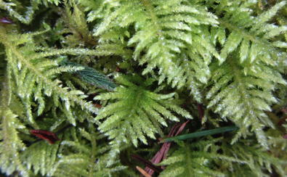
Hylocomium splendens  Stair-step or Fern moss | Pleurocarp  Soil, rotten logs  Note: new growth comes out of middle of previous year’s growth  Coniferous forest | 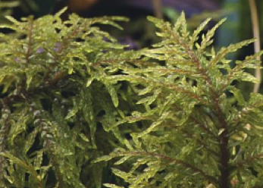
Isothecium myosuroides  Cat tail moss | Pleurocarp  Rotten logs, rock, trees-conifers & hardwoods  Note: 2 forms, one with long narrow strands  Coniferous forest | 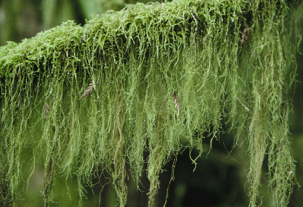
Leucolepis acanthoneuron (menziesii)  Menzies’ tree moss | Acrocarp  Soil, logs, tree bases  Note: look like little trees  Coniferous forest, riparian | 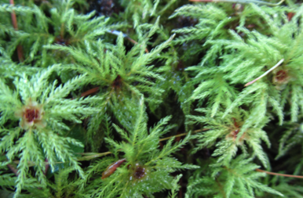
Neckera (Metaneckera) menziesii  Menzie’s neckera | Pleurocarp  Hardwood trunks, rocks  Note: undulate leaves, looks like Neckera douglasii, but has costa and is larger  Coniferous forest | 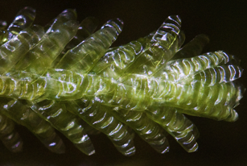
Neckera douglasii  Douglas’s neckera | Pleurocarp  Hardwood trunks  Note: undulate leaves, silvery cast, small | 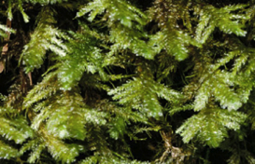
Orthotricum lyellii  Lyell’s bristle moss | Acrocarp  Hardwood trunks & branches  Note: forms tufts  Coniferous forest, hardwood trees | 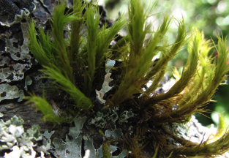
Plagiomnium insigne  Badge moss | Acrocarp  Rotten logs, soil, humus, tree bases  Note: large, fern-like  Coniferous forest | 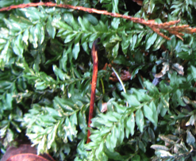
Plagiothecium (Buckiella) undulatum  Snake moss, Cotton moss | Pleurocarp  Rotten logs, tree bases  Note: flattened, silvery, undulate leaves  Coniferous forest | 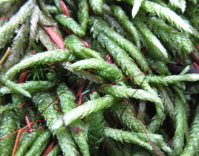
Polytrichum juniperinum  Hair cap moss | Acrocarp  Soil  Note: red bristle point  Open areas, sun to part shade | 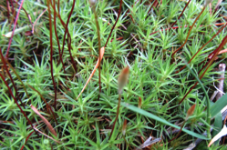
Porella navicularis  Leafy liverwort | Not a moss, but a liverwort  Hardwood trunks, roofs  Note: flattened, lobes  Wet areas | 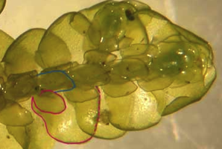
Rhizomnium glabrescens  Fan moss | Acrocarp  Rotten logs  Note: | 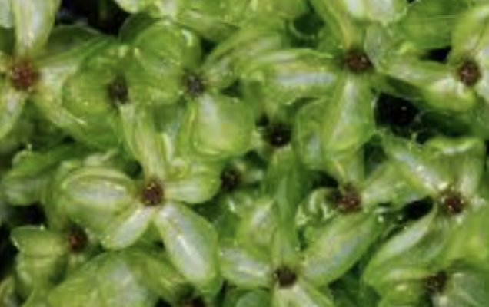
Rhytidiadelphus squarossus | Acrocarp  Soil, in grass  Note: looks like stars from above  Coniferous forest, open areas | 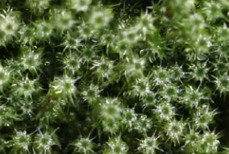
Rhytidiadelphus triquertus  Electrified cat tail moss | Acrocarp  Soil, in grass, tree bases  Note: tufts at top, red stem  Open areas, base of trees, riparian | 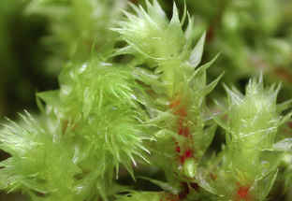

Lichens
Caloplaca sp.  Waxy firedot lichen | Crustose  Rock  Note: no leafy structures  Often seaside | 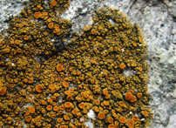
Chrisothrix candelaris  Gold dust lichen | Crustose  Trees, coniferous & hardwoods, riparian area  Note: looks like dust, bright yellow  Forests | 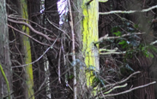
Cladonia bellidiflora  Toy soldiers | Club  Stumps, rocks, soil  Note: heavily squamolose, red tip | 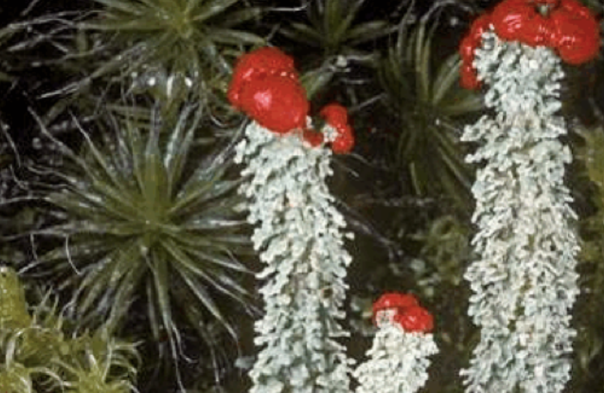
Cladonia chlorophaea  False pixie cup | Club  Soil, moss, wood, tree bases  Note: coarse soredia  Sun & part shade | 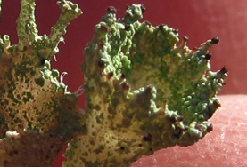
Cladonia furcata  Many-forked Cladonia | Club  Soil, moss, rotten wood  Note: upright, branched, brown apothecia  Sun & part shade | 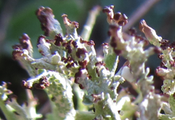
Cladonia macilenta  Lipstick Cladonia | Club  Conifer bark, wood  Note: several Cladonias have red apothecia, all have “lipstick Cladonia” as one common name  Conifer bark | 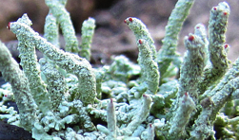
Evernia prunastri  Antlered perfume  Oak moss | Foliose  Trees, coniferous & hardwoods, shrubs  Note: top is green, bottom is white  Sun & part shade | 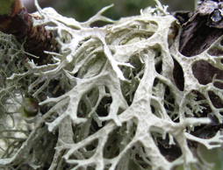
Graphis scripta  Pencil mark lichen | Crustose  Hardwoods, smooth bark (Alder)  Note: easily recognized | 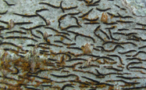
Hypogymnia imshaugii  Forking bone lichen | Foliose  Bark & wood, conifer twigs  Even forking, beautiful patterns | 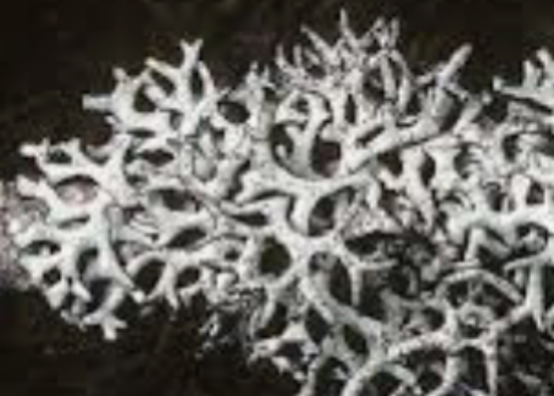
Hypogymnia physodes  Hooded bone lichen | Foliose  Trees, coniferous & hardwoods, shrubs  Note: small, tips exploded with soredia  Widespread | 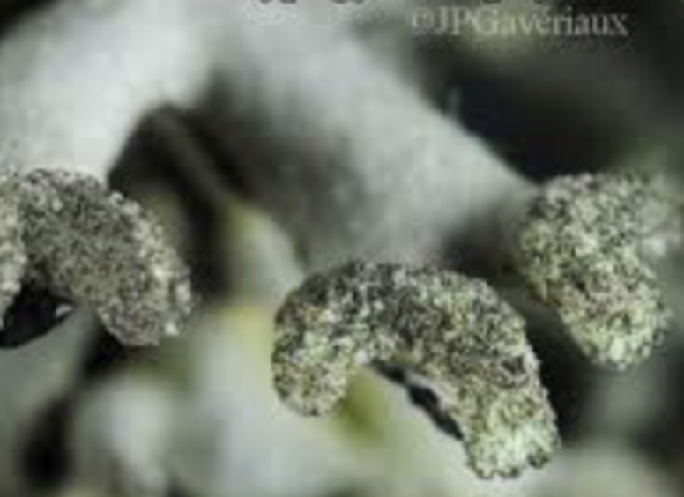
Hypogymnia tubulosa  Powder-headed tube lichen  . | Foliose  Trees, coniferous & hardwoods  Note: small, tips with soredia, often with H. physodes | 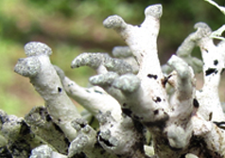
Lepraria sp.  Blue dust lichen | Crustose  Trees, coniferous  Note: Fluffy, pale, blue-green  Widespread | 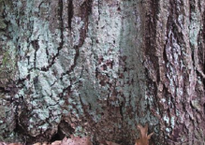
Lobria pulmonaria  Lungwort lichen | Foliose  Trees, conifers & hardwoods, shrubs  Note: circular openings on margins | 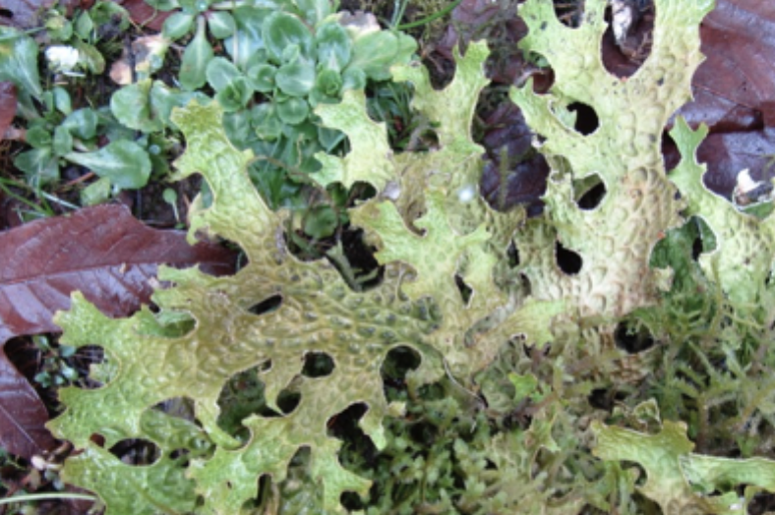
Melanelixia sp.  Camouflage lichen | Foliose  Shrubs & hardwood twigs  Note: almost disappears on brown bark | 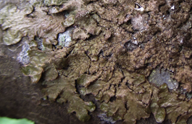
Ochrelechia laevigata  Smooth saucer lichen | Crustose  Smooth hardwood bark (Alder)  Note: thick rim, ochre color in center | 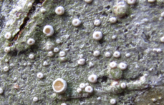
Parmelia sulcata  Waxpaper lichen | Foliose  Trees –coniferous & hardwoods, rock  Note: black rhizines, network of white lines  Widespread | 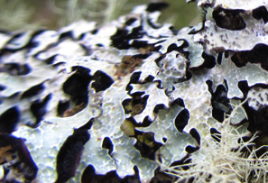
Peltigera membranacea  Felt lichen | Foliose  Soil, moss, rotten logs  Note: surface tomentose, rhizines white | 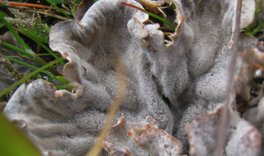
Peltigera neopolydactyla  Frog pelt lichen | Foliose  Soil, moss, rotten logs, rock  Note: surface dark, lower surface cottony, with rhizines | 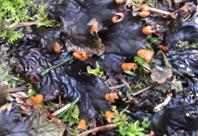
Pertusaria amara  Bitter wart lichen | Crustose  Trees, coniferous & hardwoods (Alder), rock  Note: fuzzy balls (soredia) very bitter to taste | 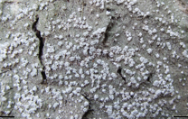
Platismatia glauca  Ragbag lichen | Foliose  Trees, coniferous & hardwoods  Notes: lower surface smooth, white to brown  Open forest | 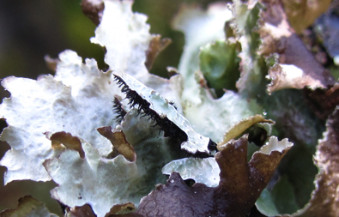
Ramalina farinacea  Several species in our area | Fruticose  Trees, coniferous & hardwoods, shrubs  Notes: all surfaces the same color, soredia on edges | 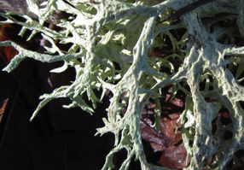
Trentepholia aurea  Terrestrial algae | Not a lichen, but an algae  Hardwoods, especially Alder  Note: small feathery tufts, photobiont in Graphis scripta | 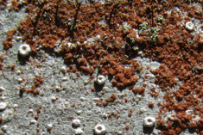
Tuckermanopsis (Cetraria) orbata  Variable wrinkle lichen | Foliose  Trees, mainly coniferous  Note: marginal pycnidia | 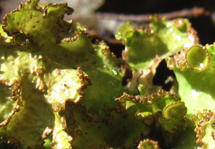
Usnea sp.  Several species in our area,  some shrubby, some pendulous | Fruticose 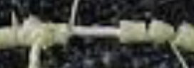  Trees, coniferous & hardwoods, shrubs  Note: All Usneas have a central core. Pull gently sideways on main stem and the surface will split to reveal the cord 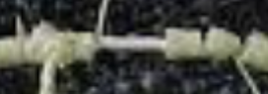 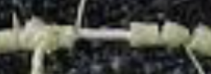 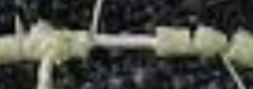 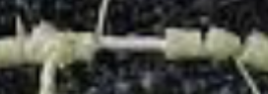 | 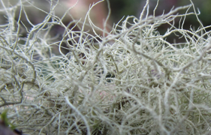
Usnea fillipendula (dasopoga)  Fishbone beard lichen | Fruticose  Trees, mainly coniferous  Note: has fibrils, isidia, papillae, fairly long | 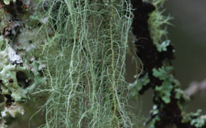
Usnea longissima  Methusella’s beard | Fruticose  Bark & wood  Note: can be 6 ft. long | 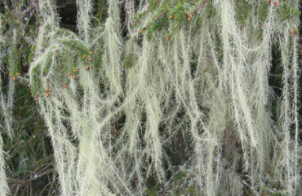
Zanthoria sp. | Foliose  Twigs & branches  Note: orange to yellow-orange color, leafy structures | 